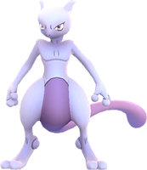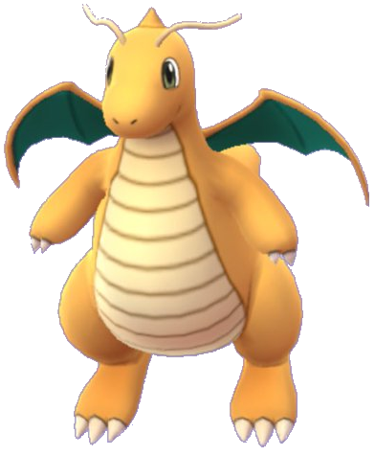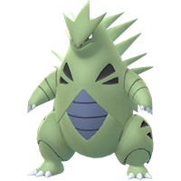

Pokémon Go Trainers!
Join our Discord group to be instantly notified about raids going on at this gym, as well as any gyms in Saginaw, Lake Worth, Haslet, Eagle Mountain, Rhome, Boyd, and more! You can even coordinate raid groups with other trainers in your area.

Use this QR code or the link below to join!
https://discord.gg/pRg9RrB
-TR_Jessie / TRBrianna

